# Algorithm for file updates in Python

## Project description

In this sample organization, there exist restricted patient records and files that are opened up to users who’s IPs are on an allowed list. There also exists a remove list which contains IPs that must be removed from the allowed list.

## Open, read, and convert string file into list

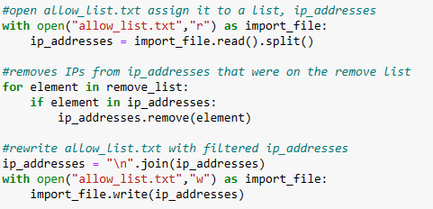

I used the .open() function with the file allow_list.txt and an argument ‘r’ to open the file and declare that I will read it in the body of the with statement. The file was opened as import_file, and promptly read, converting the file into a string. It was then split, converting that string into a list.

## Iterate and remove IP addresses that are on the remove list



The algorithm began by iterating through the remove_list by using a for loop, viewing each element one at a time. In each iteration, an if statement is executed, checking whether each iteration’s element was present in ip_addresses. If the statement returned true, or that the element was present, the element was removed from the ip_addresses list.

## Update the file with the revised list of IP addresses



To update the original file allow_list.txt with ip_addresses, I first used the .join() function to change the list into a string, separating each list element with a new line, hence the “\n”. “allow_list.txt” was once again as import_file, but with “w” as the second argument in order to write on the file. In the with statement, the file was rewritten/updated to ip_addresses with the .write() function.

## Summary

In this update, the list of IP addresses was algorithmically changed to remove addresses that were specified on the remove list. This was done by first opening the allowed list to read, and converting it into a string and then into a list where each element was an ip address. Next, the remove list was iterated through, and if one of the addresses from that list was present in the allowed list of addresses, it was removed from the allowed list. The allowed list was then converted into a string to fit into a .txt file. Finally, the original allowed list file was opened again with write permissions, and was overwritten by the allowed list string.